Measurement and Characterization of a 5T Solenoid Field

by

Jason Morgan

Measurement and Characterization of a 5T Solenoid Field

A Senior Thesis Submitted to the Faculty of the Department of Physics

Old Dominion University in Partial Fulfillment of the

Requirement for the Degree of

BACHELOR OF SCIENCE

# OLD DOMINION UNIVERSITY

April 2018

Approved by:

________________________

Dr. Sebastian Kuhn(Advisor)

________________________

Dr. Alexander Godunov

________________________

Dr. Stephen Bueltmann

#### ABSTRACT

Measurement and Characterization of a 5 T Solenoid Field

Jason Morgan

Old Dominion University, April 2018

Advisor: Dr. Sebastian Kuhn

This project involved analyzing the magnetic field generated by the 5T Solenoid magnet in the CLAS12 detector. This is being done to understand the variances from specifications of the magnetic field due to manufacturing and/or installation defects. The data was analyzed to find the center of the field using the symmetry of the magnetic field in a solenoid.

Copyright, 2018, by Jason Morgan, All Rights Reserved.

# This thesis is dedicated to my wife Isabel.

## **ACKNOWLEDGMENTS**

I would like to thank Professor Kuhn for advising me for this Senior Thesis. I would also like to thank Victoria Lagerquist for all of her assistance in getting the information and data I required to complete this task.

**TABLE OF CONTENTS**

Page

LIST OF Figures 7

LIST OF Tables 8

Chapter

I. Introduction 9

II. Field Mapping 10

III. Analysis. 12

1. Model 12
2. Run Data 13
3. Finding the Center 14
4. Scaling the Field 15

IV. Results 16

1. BZ Field 16
2. BY Field 19

C. BX Field 22

V. Conclusions and Outlook 25

1. Summary 25
2. Future Plans 25

REFERENCES 26

APPENDIXES

A. MASTER DATA FILE 27

B. CODE 27

VITA 28

**LIST OF FIGURES**

Figure 1: CLAS12 detector diagram 2

Figure 2: Super conducting solenoid 2

Figure 3: Picture of the template board positioned in solenoid. 3

Figure 4: Probe holder assembly 3

Figure 5: Another view the template board 5

Figure 6: View of hall probe holder installed in template board 5

Figure 7: Plot showing run 264 plotted with it's reflection about z=85cm with a 𝛘2 = 1.46 7

Figure 8: Plot showing run 264 plotted with it's reflection about z=85cm with a 𝛘2 = 0.0506 8

Figure 9: Bz v z at r = 0 and r = 1.25cm grouped by r, showing little difference r=0 and r=1.25cm 9

Figure 10: Bz v z at r = 0 and r = 1.25cm grouped by r in the range [-5, 5] showing little difference. 10

Figure 11: Bz vs z at r = 0 scaled with model (solid line) 10

Figure 12: Bz v z at r = 30 scaled with model 11

Figure 13: By v x at r = 0 12

Figure 14: By/Bz v z at r = 0 13

Figure 15: By v z at r = 1.25 cm scaled with model (solid line) with z corrected for 10 cm y probe offset form z probe 13

Figure 16: By v z at r = 30 cm scaled with model 14

Figure 17: By/Bz v z at 1.25 cm radius 15

Figure 18: Bx at r = 0 15

Figure 19: Bx/Bz at r = 0 16

Figure 20: Bx/Bz ar r = 1.25 cm 17

Figure 21: Bx/Bz at r = 30 cm 17

**LIST OF TABLES**

Table 1: Master Data File. See Appendix A 4

Table 2: Table of data translations performed 6

**CHAPTER 1**

Introduction

Thomas Jefferson National Accelerator Facility (Jefferson Lab) is a national laboratory that is a operated and funded by the U.S. Department of Energy. The purpose of the facility is to study the internal structure of nuclei using high energy electron beams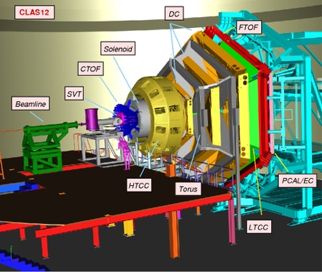. CLAS12 is the CEBAF Large Acceptance Spectrometer for 12 GeV in Hall B at Jefferson Lab (FACILITY, 2018).

Figure 1: CLAS12 detector diagram

The purpose of CLAS12 is to detect the products of interactions between the electron beam and nuclear targets. There are a large number of subsystems that are used to detect and track the particles produced in collisions. CLAS12 is an upgrade to the CLAS detector to support science with the 12 GeV electron beam. The CLAS12 consists of two subsystems, the Forward Detector and the Central Detector. The forward detector is constructed around a 3.58T toroidal magnet. The central detector utilizes a 5T super conducting solenoidal magnet that is the subject of this thesis (Lab, 2018).

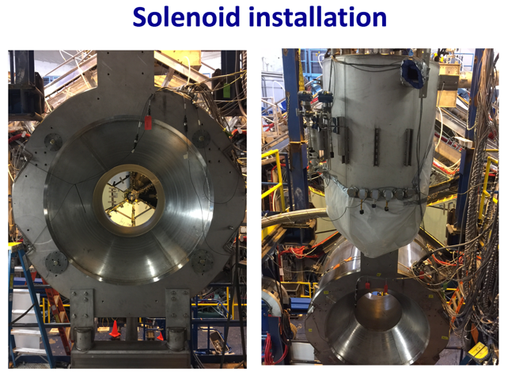The purpose of the solenoid is to shield the detectors from background and also to analyze the momenta of particles leaving the target at large angles. This magnet is a super conducting solenoidal magnet. It is constructed using 5 coils: 4 main coils and 1 shield coil. The solenoid has a central field of 5T and a peak field of 6.56T (Lab, 2018).

Figure 2: Super conducting solenoid

The solenoid was installed in September 2017. The field the solenoid produced was then mapped using a dedicated apparatus. In this thesis we attempt to analyze the mapping data to understand the nature of the field inside the solenoid and how it aligns with the theoretical model.

**CHAPTER 2**

Field Mapping

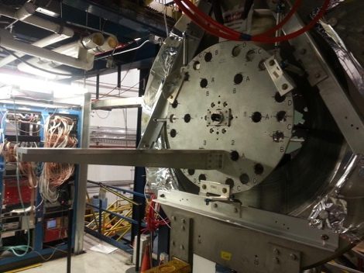The magnetic field produced by the solenoid was mapped using Hall probes placed in carbon tubes inserted into a template board. This board holds the probes at specified locations around and along the center axis of the solenoid. The positions measured were along the center line (r = 0), r = 1.25 cm from the center line, and r = 30 cm from the center line at 30, 45, 90, 135, 150, 180, 210, 235, 270, 310 and 330 degrees.

Figure 3: Picture of the template board positioned in solenoid.

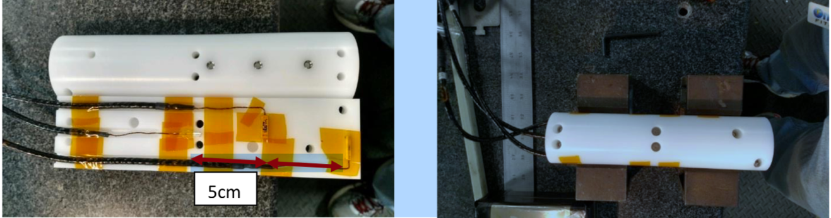

Figure 4: Probe holder assembly

Additionally, the probes were rotated for some runs. This was done by the measurement team to ensure repeatability of the systems. Doing this causes the field components to be measured by different Hall probes for the phi component and the radial component of the magnetic field inside the solenoid. The Hall probe assembly held three hall probes. Each probe measured one component (x, y, z) and were offset by 5 cm relative to each other.

There were several 38 runs of data that were provided for this analysis. The runs were conducted in two ranges, long runs and short runs. The short runs were conducted in 1 mm steps. The long runs were conducted in 1 cm steps and 2 cm steps.

Table 1: Master Data File. See Appendix A

|  |  |  |  |  |  |  |  |  |  |  |  |
| --- | --- | --- | --- | --- | --- | --- | --- | --- | --- | --- | --- |
| Run | CenterZ | Hole | Current | r | theta | full | pr | Sensor Measuring Br | RunLength | Good | FittedCenterZ |
| 258 | 90 | A | 100 | 1.25 | 0 | 1 | 0 | Y | L | N | 90.19 |
| 259 | 90 | A | 500 | 1.25 | 0 | 1 | 0 | Y | L | N | 90.22 |
| 260 | 90 | A | 900 | 1.25 | 0 | 1 | 0 | Y | L | N | 90.22 |
| 261 | 90 | A | 1000 | 1.25 | 0 | 1 | 0 | Y | L | N | 90.22 |
| 262 | 116 | A | 0 | 1.25 | 0 | 1 | 0 | Y | L | N |  |
| 264 | 90 | A | 1450 | 0 | 0 | 1 | 0 | Y | L | Y | 90.36 |
| 270 | 54 | A | 1450 | 0 | 0 | 0 | 0 | Y | S | Y | 52.6 |
| 271 | 90 | A | 1450 | 0 | 0 | 1 | 0 | Y | L | Y | 90.37 |
| 273 | 90 | B | 1450 | 1.25 | 0 | 1 | 0 | Y | L | Y | 90.36 |
| 274 | 53 | B | 1450 | 1.25 | 0 | 0 | 0 | Y | S | Y | 53.79 |
| 275 | 90 | A | 1450 | 1.25 | 90 | 1 | 0 | Y | L | Y | 90.2 |
| 276 | 49 | A | 1450 | 1.25 | 90 | 0 | 0 | Y | S | N |  |
| 277 | 90 | A | 1450 | 1.25 | 90 | 1 | 90 | X | L | Y | 90.2 |
| 279 | 90 | A | 1450 | 1.25 | 180 | 1 | 0 | Y | L | Y | 90.37 |
| 280 | 53 | E | 1450 | 1.25 | 180 | 0 | 0 | Y | S | Y | 55.34 |
| 281 | 52 | A | 1450 | 1.25 | 270 | 0 | 0 | Y | S | Y | 50.42 |
| 282 | 90 | A | 1450 | 1.25 | 270 | 1 | 0 | Y | L | Y | 90.29 |
| 283 | 53 | A | 1450 | 1.25 | 90 | 0 | 0 | Y | S | Y | 54.43 |
| 284 | 54 | C | 1450 | 1.25 | 45 | 0 | 0 | Y | S | Y | 55.25 |
| 285 | 54 | C | 1450 | 1.25 | 45 | 0 | 0 | Y | S | Y | 54.29 |
| 286 | 90 | C | 1450 | 1.25 | 45 | 1 | 0 | Y | L | Y | 90.3 |
| 289 | 51 | D | 1450 | 1.25 | 135 | 0 | 0 | Y | S | Y | 52.93 |
| 291 | 90 | D | 1450 | 1.25 | 135 | 1 | 0 | Y | L | Y | 90.26 |
| 292 | 90 | F | 1450 | 1.25 | 225 | 1 | 0 | Y | L | Y | 90.35 |
| 293 | 54 | F | 1450 | 1.25 | 225 | 0 | 0 | Y | S | Y | 53.64 |
| 294 | 90 | G | 1450 | 1.25 | 315 | 1 | 0 | Y | L | Y | 90.3 |
| 295 | 53 | G | 1450 | 1.25 | 315 | 0 | 0 | Y | S | Y | 51.2 |
| 296 | 89 | A | 1450 | 30 | 330 | 1 | 0 | Y | L | Y | 88.79 |
| 298 | 89 | A | 1450 | 30 | 30 | 1 | 0 | Y | L | Y | 88.82 |
| 299 | 90 | A | 1450 | 30 | 90 | 1 | 0 | Y | L | Y | 89.1 |
| 301 | 89 | A | 1450 | 30 | 150 | 1 | 0 | Y | L | Y | 88.81 |
| 303 | 89 | A | 1450 | 30 | 210 | 1 | 0 | Y | L | Y | 88.75 |
| 305 | 87 | A | 1450 | 30 | 210 | 1 | 90 | X | L | Y | 88.8 |
| 307 | 88 | A | 1450 | 30 | 210 | 1 | 180 | Y | L | Y | 88.05 |
| 308 | 90 | A | 1450 | 0 | 0 | 1 | 0 | Y | L | Y | 90.28 |
| 309 | 90 | A | 1450 | 0 | 0 | 1 | 90 | X | L | Y | 90.26 |
| 310 | 90 | A | 1450 | 0 | 0 | 1 | 180 | Y | L | Y | 90.15 |
| 311 | 90 | A | 1450 | 0 | 0 | 1 | 270 | X | L | Y | 90.32 |

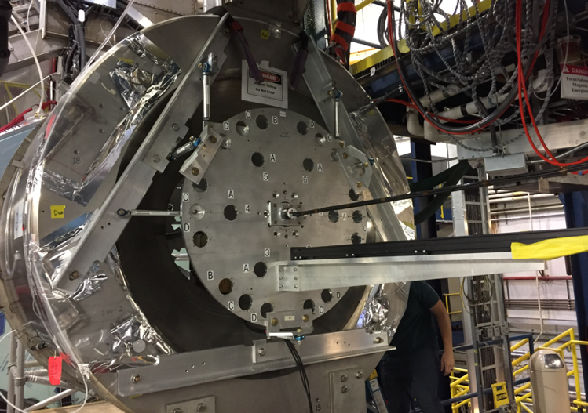

Figure 5: Another view the template board

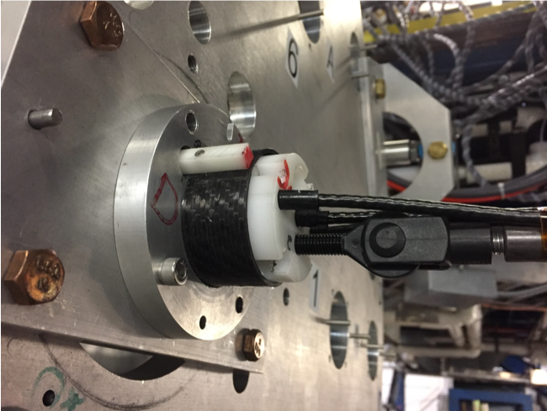

Figure 6: View of hall probe holder installed in template board

**CHAPTER 3**

Analysis

**Model**

A model of the magnetic field, calculated in 3 dimensions, was provided by the manufacturer in a single file containing a grid of longitudinal and transverse points, giving the By and Bz field components. The grid points were given in mm and the fields in Tesla. These were translated into coordinates matching the measurement data: longitudinal (mm) changed to z (cm), transverse (mm) changed to r (cm), Br (T) changed to By (Gauss) and Bz (T) change to Bz (Gauss). The model did not contain an azimuthal component since theoretically it should be zero everywhere. A Bx component was added and set to zero to allow for the data to have the same fields as the run measurements.

**Run Data**

The data was collected in Excel files representing each run. These contained two tabs with the run data and run information. A separate file with run properties was also produced (see appendix). The run properties file contained information about: the radial distance, the angle of the sector, the angle the probe was rotated by in the probe holder and whether the run was short or full. This was utilized to align the data with the proper coordinates.

Table 2: Table of data translations performed

|  |  |  |
| --- | --- | --- |
| **Probe Rotation (pr)°** | **NormalizedBx =** | **NormalizedBy =** |
| **0** | **Bx** | **By** |
| **90** | **By** | **-Bx** |
| **180** | **-Bx** | **-By** |
| **270** | **-By** | **Bx** |

There are several runs that were not used in this analysis. There is one run with a current of zero. There is one run that appears to show the solenoid powering down during the run. There are also four warm up runs that were performed at currents of 100, 500, 900 and 1000. These runs were flagged as not good and excluded from the analysis.

**Finding the Center**

To properly overlay the different runs they need to be aligned sharing a common longitudinal/z coordinate. This was accomplished by leveraging the symmetry of the magnetic field in the solenoid. The data set was reflected about several *z* values in the run data, selected within a range in the obvious center of the field. The reflection that had the minimum χ2 was selected as the center for that run. This has the limitation that the steps are integral and the center could actually lie somewhere in between points.

To deal with this, the χ2 value was calculated for several points of reflection. These values were then fitted with a quadratic fit using the R lm function. The resulting model was used to predict the χ2 in 0.01 cm steps and find the optimum z-value of the center with the minimum χ2.

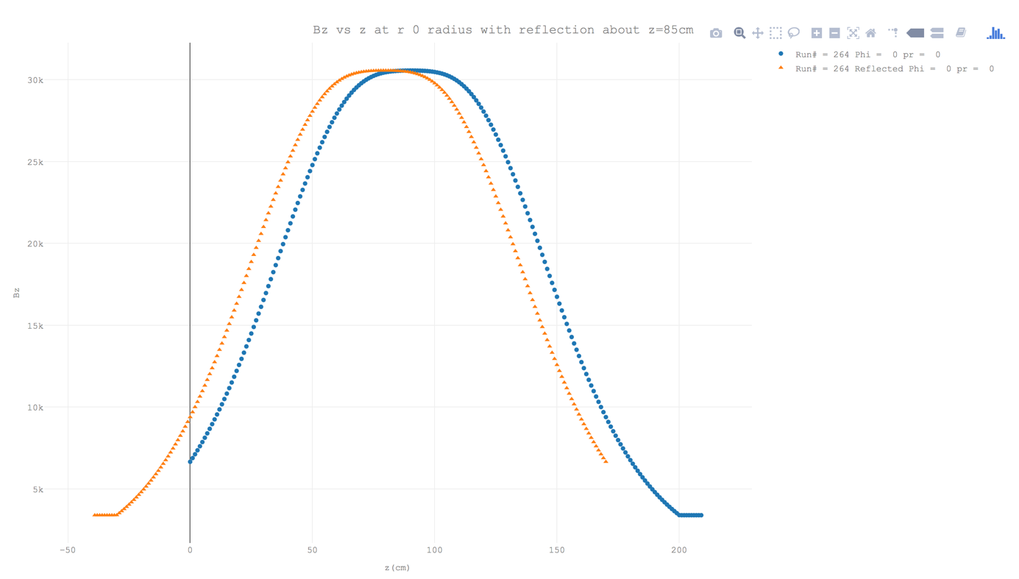

Figure 7: Plot showing run 264 plotted with it's reflection about z=85cm with a 𝛘2 = 1.46

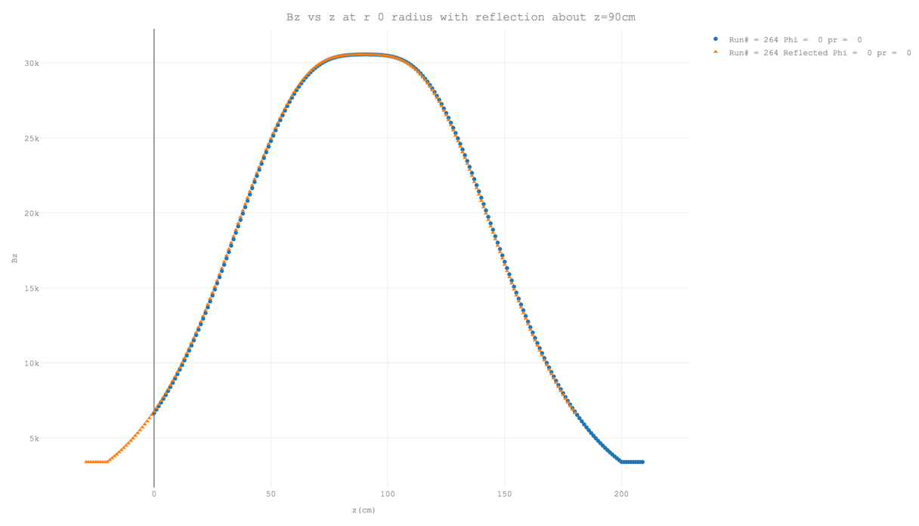

Figure 8: Plot showing run 264 plotted with it's reflection about z=85cm with a 𝛘2 = 0.0506

This centering was done using the Bz field measurements. The measurements from the By and Bz fields were not able to be fitted for center at the time of this writing. The Bz centering was used for the By and Bz fields as well. When looking at these

measurements, it appeared that the By and Bx Hall probes were offset from each other as well as the Bz probe. It was later confirmed that there is a 5 cm offset between the Bz, By and Bx sensors. The center z was found to have a mean of 89.8 ± 2.3 cm for the long runs and a mean of 53.4 mm ± 5.0 mm.

**Scaling The Field**

The field Bz and off-center By measurements were also scaled in order to compare to the model. This was done by getting the ratio of maximum model field value for a given radius and multiplying the field measurements by this ratio. Since By at r=0 and Bx for all r are predicted to be zero, scaling does not make sense and was not applied for that data.

**CHAPTER 4**

Results

**Bz Field**

The By field is very consistent between r = 0 and r = 1.25 cm. When plotted simultaneously, the data points all lie on top of each other. This aligns with the model which predicts the maximum Bz field to be 0.30 Gauss greater at r = 1.25 cm than at r = 0. The mapping shows the maximum Bz field to be 0.61 Gauss greater at r = 1.25 cm than at r = 0, which is within the measurement uncertainty.

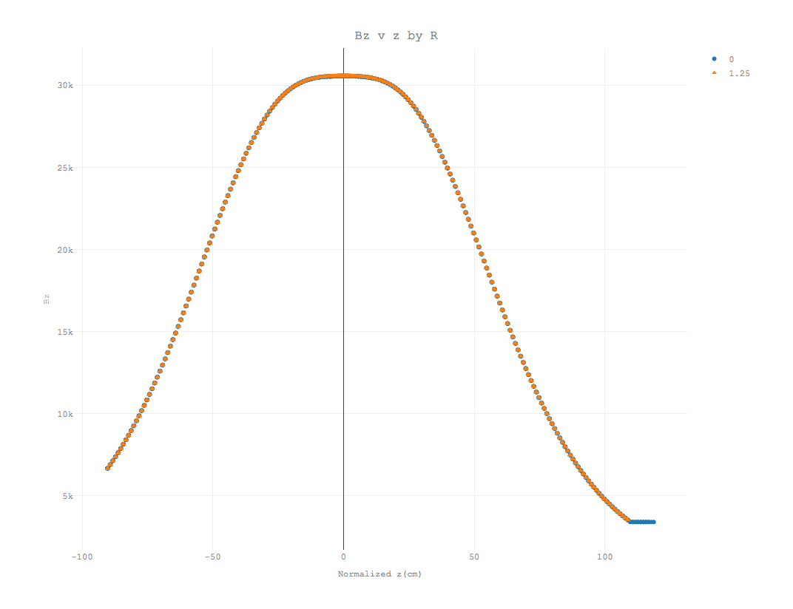

Figure 9: Bz v z at r = 0 and r = 1.25cm grouped by r, showing little difference r=0 and r=1.25cm

Zooming into the region between -5 and 5 cm further illustrates this. 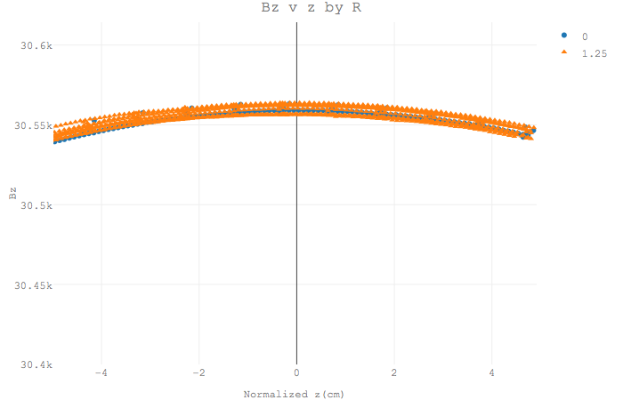

Figure 10: Bz v z at r = 0 and r = 1.25cm grouped by r in the range [-5, 5] showing little difference.

The Bz field at r = 0 closely aligns with the model field when scaled between -10 and 10 cm about the center of the field. In this range, there is less than 0.2% variance from the model data. Outside of this range, the measured field is narrower than the model.

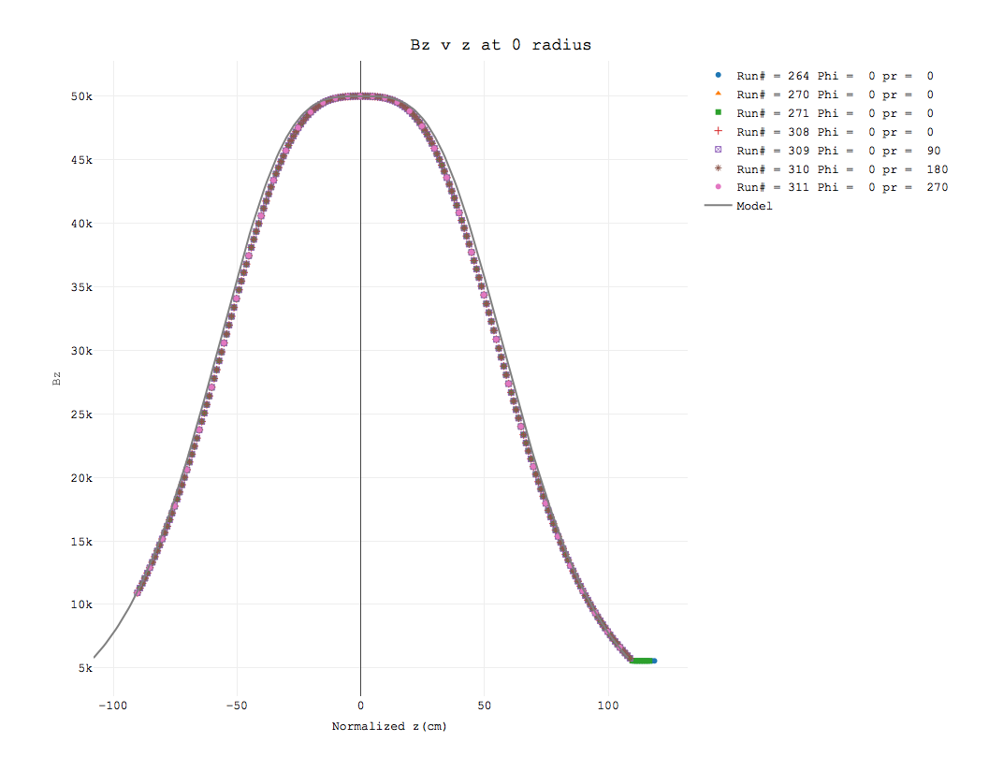

Figure 11: Bz vs z at r = 0 scaled with model (solid line)

The same holds true for the Bz field at r equals 1.25 cm. The field here is more aligned with the model than it is at r equals 0. The variance from the model is less than 0.2% between the range of -30 and 30 cm about the center of the field. The data for r equals 30 cm has a similar fit to the model as the data at r equals 0 and r equals 1.25 cm. It is narrower than the model and the variance with the model is less than 0.2% on the range -70 to +70 cm.

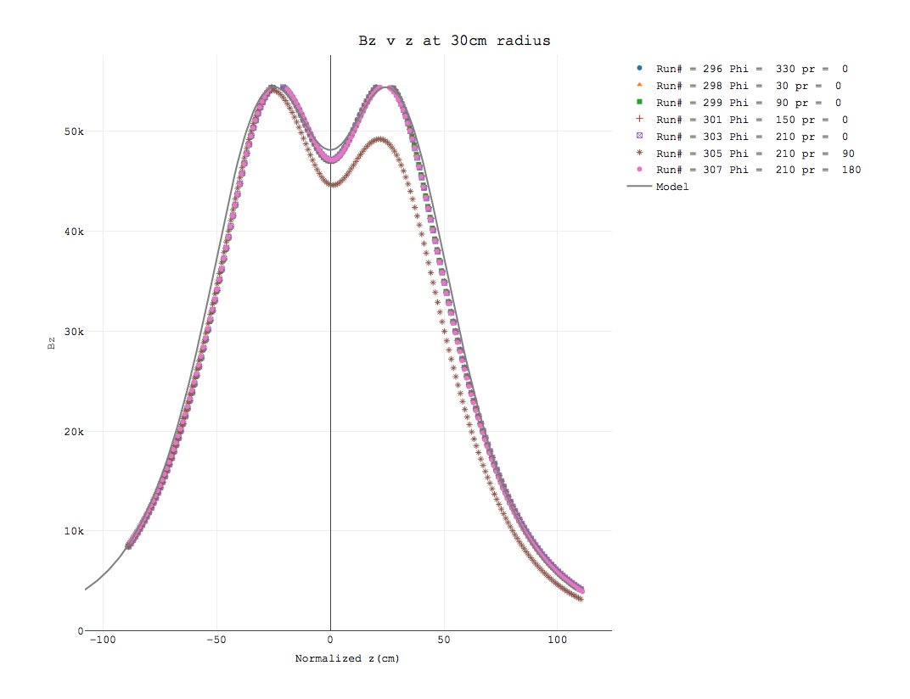

Figure 12: Bz v z at r = 30 scaled with model

Run 305 is the exception. It tracks like the rest of the run until the first peak at z equals −29.8 cm. The reason for this has not been conclusively identified but it looks like the current was ramped down mid run. The peaks the other runs are missing due to saturation of the Hall sensors above 5.4 T.

**By Field**

The By field was measured and is offset by 5 and 10 cm from the Bz field measurements. To compensate for this, a normalized z was calculated for the By plots. This subtracted 5 cm from the reported z if the probe was measured with the By probe and 10 cm if the By field was measured with the Bx probe.

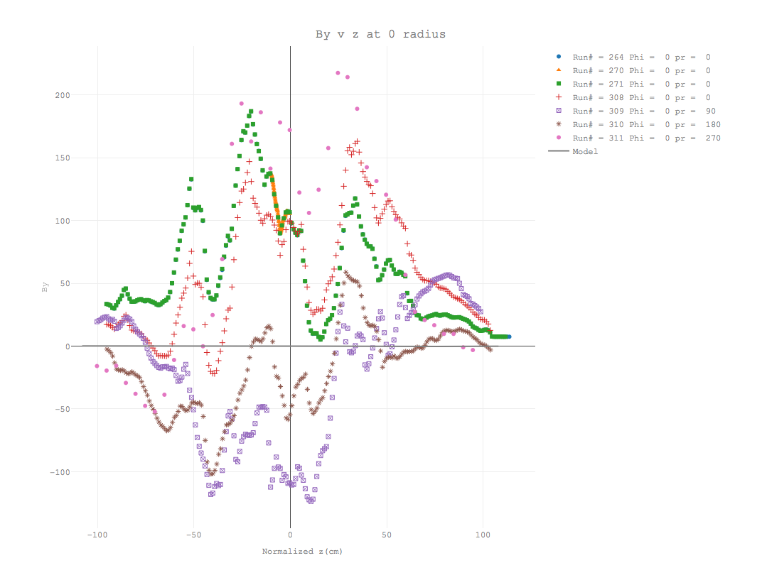

Figure 13: By v x at r = 0

There appears to be a correlation between By and the motion of the Hall probe holder along the z axis. As can be seen in Figure 12 below, the ratio of By/Bz varies with z having periodic peaks and valleys. This looks like it is caused by some wobble in the probe holder as it moves along the axis, causing the By Hall probe to periodically pickup more and less of the Bz component.

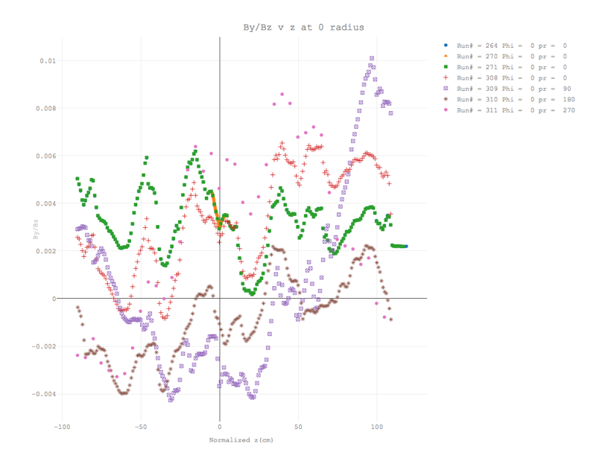

Figure 14: By/Bz v z at r = 0

The plot of By at r = 1.25 cm shows the periodic wobble of the probes with the periodic peaks. It initially appeared that this plot was offset 10 cm to the right. After correcting for the offset, the plot matches well with the model with the exception of the effect of probe wobble.

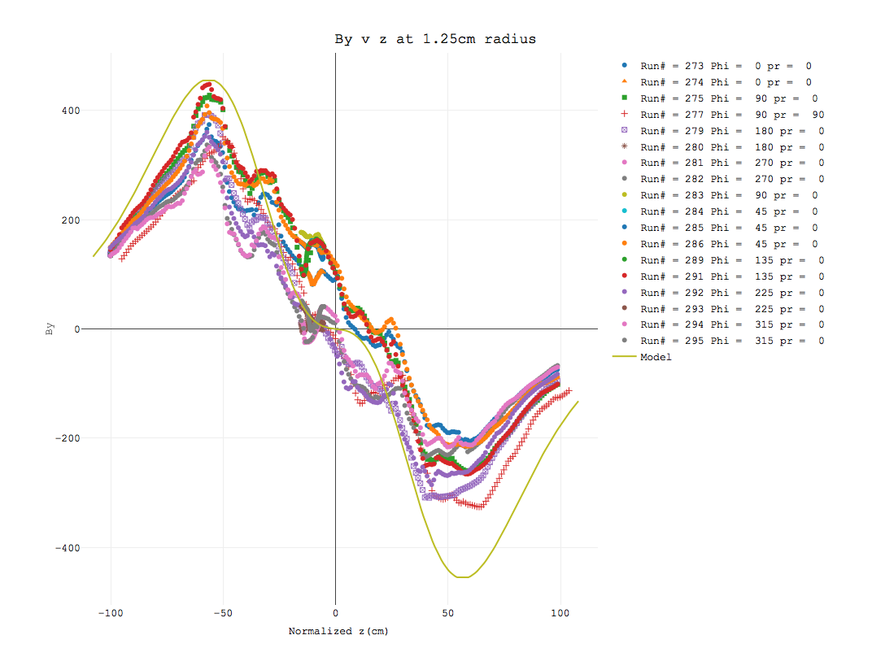

Figure 15: By v z at r = 1.25 cm scaled with model (solid line) with z corrected for 10 cm y probe offset form z probe

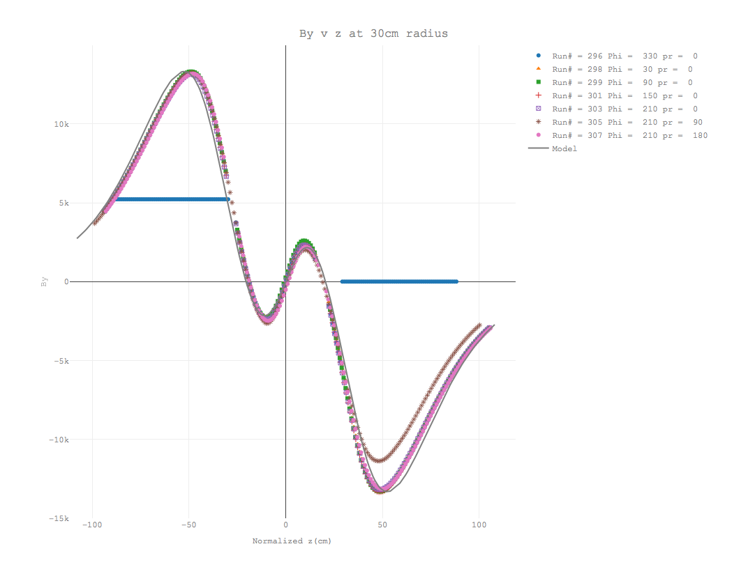

Figure 16: By v z at r = 30 cm scaled with model

Run 305 deviates more from the rest of the runs just as it did for the Bz field. Like with the Bz data, this run deviates more from the model as z increases. The deviation in By for this run starts at a higher z value than Bz measurements did starting at 32.2 cm. Run 296 has clear issues in measurement. It is fixed at 5,218 Gauss from z equals −88.8 cm to −29.8 cm and it is fixed at 0 from z equals 29.2 cm to 88.2 cm.

The 1.25 cm plot of By/Bz is less evident of the probe displacement. The field here shows a clear linear dependence on z.

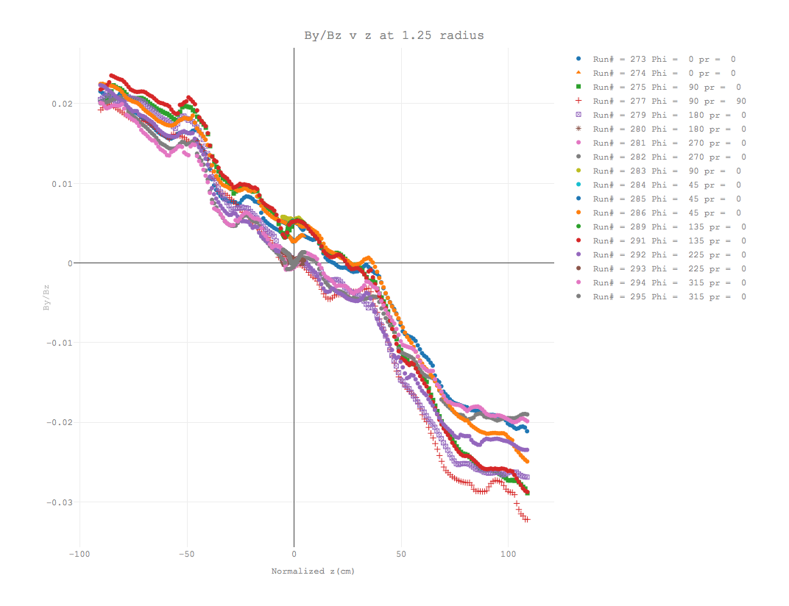

Figure 17: By/Bz v z at 1.25 cm radius

**Bx Field**

The Bx field is expected to be non-existent for all values of z and r. The measured field has fluctuations in ±200 Gauss range. There does appear to be some correlation between the Bx and Bz data shown in Figure 17.

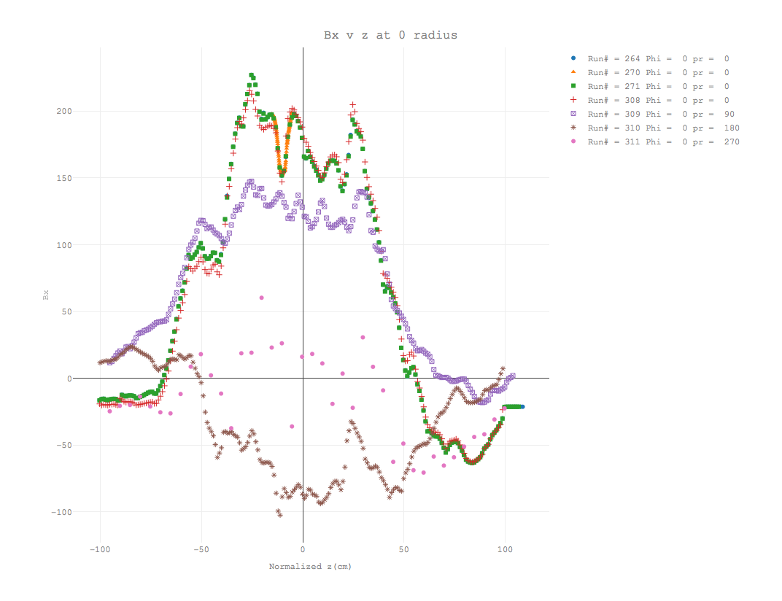

Figure 18: Bx at r = 0

This could be attributed to misalignments of the Hall probes causing the Bx probe to pickup some of the Bz field component.

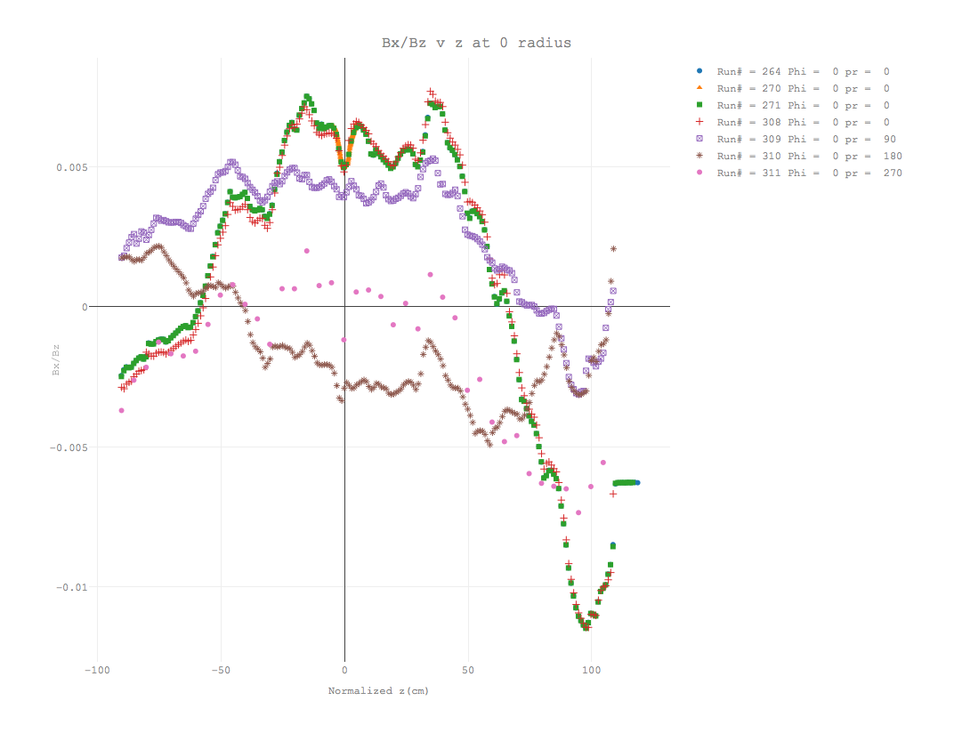

Figure 19: Bx/Bz at r = 0

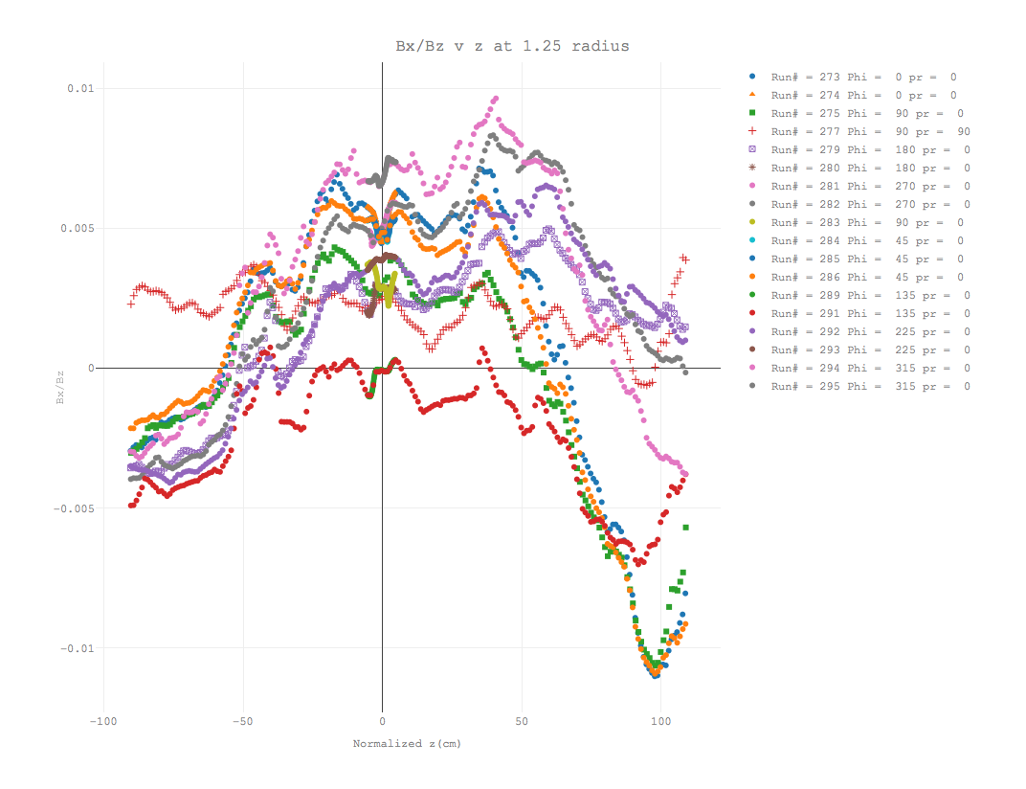

Figure 20: Bx/Bz ar r = 1.25 cm

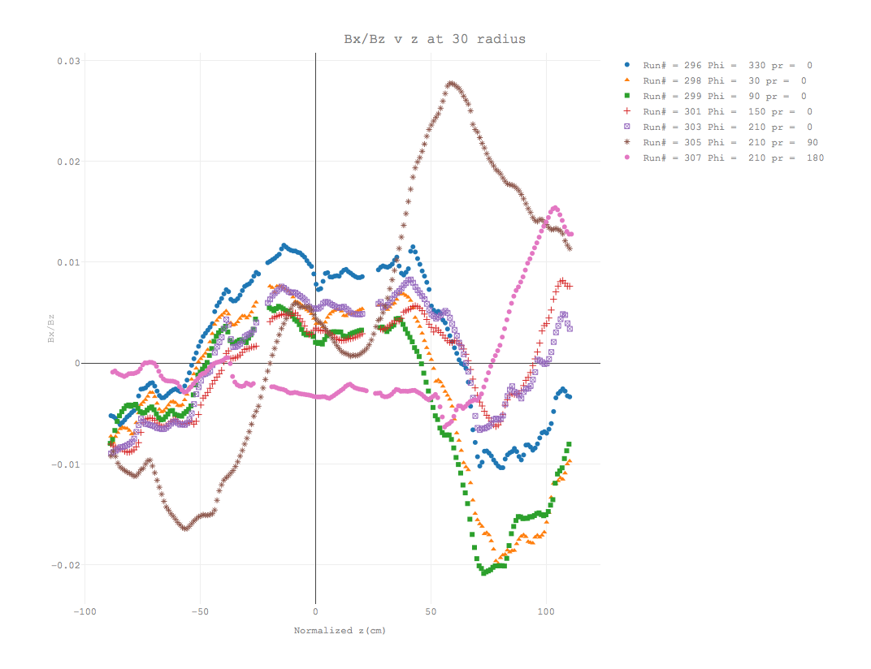

Figure 21: Bx/Bz at r = 30 cm

**CHAPTER 5**

Conclusion and Outlook

**Summary**

The center z values were found to vary by as much as 2.3 cm for the long runs and 0.50 cm for the short runs. The center of the field is known to within 4.6 cm for the long runs and 1.0 cm for the short runs. Bx field is within ±400 Gauss of the model as is the By field. There is a definite dependence of By and Bx on Bz. This indicates that there was some motion of the probe holder other than longitudinal as it moved down the z axis.

**Future Plans**

More analysis needs to be done to isolate the contribution caused by the physical wobble of the probe holders on By and Bx field components. This will allow the data in the runs to be corrected for the wobble. This allow for the noise to be removed from the model. Then a parameterization of the deviations from the model field can be developed to improve our knowledge of the field inside the solenoid.

# **REFERENCES**

FACILITY, T. J. N. A., 2018. *Lab Overview | Jefferson Lab.* [Online]   
Available at: https://www.jlab.org/about

Lab, J., 2018. *Jefferson Lab, Experiment Hall B.* [Online]   
Available at: https://www.jlab.org/Hall-B/clas12-web/

**APPENDICES**

**Appendix A: Master Data File**

The master data file contains information on all runs and the different translations performed on the data. There is a “Run Information” tab that has summary information on each run. The full file can be found in the source repository here: [Master Data File.xlsx](https://github.com/framingeinstein/Senior-Thesis/blob/master/Master%20Data%20File.xlsx?raw=true)

**Appendix B: Code**

The project utilized the R programing language for data processing and analysis. All code produced to facilitate this thesis is maintained under version control in a git repository on <https://github.com/framingeinstein/Senior-Thesis>.

**VITA**

Jason Morgan

Department of Physics

Old Dominion University

Norfolk, VA 23529

Education:

Old Dominion University

* Bachelors of Science Candidate in Physics, 1996 – Present

Anne Arundel Community College

* Associates, 2008

Work Experience:

Master Data Developer/Analyst – Trader Interactive, 2016 – Present

Independent Consultant – Data Analytics/Machine Learning, 2014 – Present

Manager of Software Development – Travel Advantage Network, 2009 – 2015

Senior Software Developer – Congruent Media, 2006 – 2009